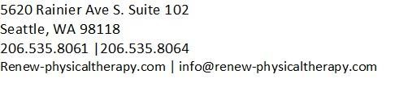

KOOS, JR. KNEE SURVEY
INSTRUCTIONS: This survey asks for your view about your knee. This information will help us keep track of how you feel about your knee and how well you are able to do your usual activities. Answer every question by ticking the appropriate box, only one box for each question. If you are unsure about how to answer a question, please give the best answer you can.

Stiffness: The following question concerns the amount of joint stiffness you have experienced during the last week in your knee. Stiffness is a sensation of restriction or slowness in the ease with which you move your knee joint.

1. How severe is your knee stiffness after first wakening in the morning?
None Mild Moderate Severe Extreme
         

Pain: What amount of knee pain have you experienced the last week during the following activities?

2. Twisting/pivoting on your knee
None Mild | Moderate | Severe | Extreme
□    3. Straightening knee fully | □ |   |  
None Mild | Moderate | Severe | Extreme
□    4. Going up or down stairs |   |   |  
None Mild | Moderate | Severe | Extreme
□    5. Standing upright |   | □ | □
None Mild | Moderate | Severe | Extreme
□   |   | □ | □

Function, daily living: The following questions concern your physical function. By this we mean your ability to move around and to look after yourself. For each of the following activities please indicate the degree of difficulty you have experienced in the last week due to your knee.

6. Rising from sitting
None Mild | Moderate | Severe | Extreme
□    7. Bending to floor/pick up an object |   | □ | □
None Mild | Moderate | Severe | Extreme
□   |   | □ | □

NAME: ______________________________________ DATE: __________________________

