PATIENT HISTORY
LAST NAME | FIRST | DATE OF BIRTH | SOCIAL SECURTIY NUMBER |  | PRONOUNS   HE/HIM  SHE/HER   THEY/THEM  DECLINE
ADDRESS |  | CITY |  | STATE | ZIP CODE
EMAIL |  | PHONE |  | How would you like to receive appointment  reminders? |  | ❐ PHONE   TEXT

EMERGENCY CONTACT & RELATION: ________________________________________________ PHONE: __________________

How did you hear about us?  Social Media  Doctor Referral  Google  Friend/Family  Neighborhood
First Name: | Last Name: | Phone #:
Referring Physician Information:

CHIEF COMPLAINT AND PRESENT ILLNESS:

Area of injury/symptoms Date your symptoms/injury started_________________

How did your symptoms start? ____________________________________________________________________________

Diagnosis from your doctor Date of your next doctor recheck ___________________

Are you currently off work because of this problem no yes; if yes, last day worked?
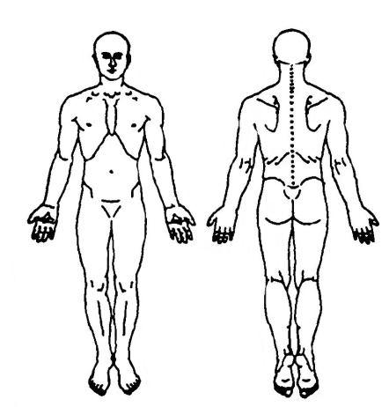
Using the diagram, circle the specific area of pain. If pain travels, draw arrows.

Please RATE your pain level. No pain 1 2 3 4 5 6 7 8 9 10 Worst pain.

Pain level at your WORST_____ BEST______ and AVERAGE_____

Please DESCRIBE your pain by circling the word or words below?

dull ache_______ burning heavy sore_____
deep ache throbbing twinge other_____
stabbing squeezing cramp______
nagging drawing sharp_______

Are your symptoms intermittent or constant? (circle one)

Do you have any numbness/tingling/weakness? Where?

Prior to this onset, were you free of these symptoms? Yes_____ No_____ Explain

What eases the pain? ______________________________________________________________

What aggravates the pain? __________________________________________________________

Have you had any other treatment for this problem? What? Chiropractic ___ Physical Therapy___ Other ___

Did it help? ____________________________________

Do you feel you are getting better, getting worse or staying the same? (circle one)

Have you had x-rays? yes no Findings?

Have you had an MRI? yes ________ no _______ Findings?

Please list any other tests you have received:

Women only: Are you pregnant? yes no Which trimester? 1 2 3

Any other concerns or health changes since the start of this injury/illness ____________________________________________

ACTIVITIES OF DAILY LIVING: Circle activities that are difficult for you and then check the appropriate box.

 | no difficulty | with difficulty/pain | cannot perform
Personal hygiene: hair, bathing, toilet
Dressing: zippers/buttons, upper body, lower body, shoes
Household chores: reach overhead, lifting/carrying, dust vacuuming, mopping,
Meal Preparation: use stove, do dishes
Yard/Garden: mowing, tilling, weeding, raking, watering
Walking: stairs, curbs, incline, decline, uneven ground, distances
Transportation: Drive self, ride with others, bus, taxi, shopping

LIST YOUR LEISURE ACTIVITIES (circle those affected by your current problem):

GENERAL MEDICAL: Have you EVER been diagnosed as having any of the following conditions?

A. Cancer YES | K. Other arthritic problems YES
If YES, describe what kind: ______________________ | L. Depression YES
B. Heart problems YES | M. Hepatitis YES
C. High blood pressure YES | N. Tuberculosis YES
D. Asthma YES | O. Stroke YES
E. Emphysema YES | P. Kidney disease YES
F. Chemical dependency (i.e. alcoholism) YES | Q. Anemia YES
G. Thyroid problems YES | R. Epilepsy YES
H. Diabetes YES | S. Insomnia YES
I. Multiple Sclerosis YES | T. Constipation/diarrhea YES
J. Rheumatoid arthritis YES | U. Skin Condition: _________________________________________

If you have been seen by any health care provider during the past 3 months for reasons other than what brought you here, please describe for what reason: __________________________________

Please list any SURGERIES you have had or any INJURIES for which you have been treated (please include approximate dates):

Please list ALL PRESCRIPTION and/or OVER-THE-COUNTER medications you are currently taking for this and any
other condition (including pills, injections, and/or skin patches): _____________________________________________________________

Do you have allergy to any medications? If yes, please list them: _____________________________________________________________

GOALS: Please list your personal goals for therapy: ______________________________________________________________________

